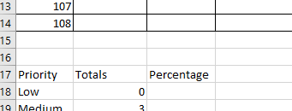

the COUNTIF function on Low of the priority of column not working, what’s wrong?